Network Topologies

Task 1:- Draw and label diagrams of star, bus, and mesh network topologies on paper or using any drawing tool. For each, write one real-world app or service (like WhatsApp, Flipkart, or IPL streaming) that could use that topology and explain why in 1-2 lines.

ANS :-

- Star Topology :-

In a Star Topology, all nodes are connected directly to a central device, such as a switch or hub. The central node acts as a server, managing all data transmission between node.
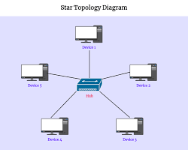
Real-World Application :- App / Service: IPL Streaming Like :- JioCinema /Disney+ Hotstar.

WHY :- A star-like structure is essential for broadcasting high-bandwidth data; millions of user devices (nodes) connect directly to a central content delivery server (hub) to receive the same live feed efficiently without affecting other users.

- Bus Topology :-

A Bus Topology uses a single central cable, known as the backbone, to which all network nodes are attached via drop lines. Data travels sequentially along the cable, and a breakdown in the backbone halts all communication.
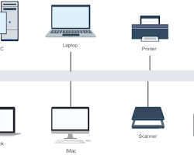

Real-World Application :- Service: Smart Meter Reading Networks (in a neighborhood).

- Why : While rare in high-speed computer networks today, bus topology is highly cost-effective and simple for linking multiple standardized low-bandwidth smart meters sequentially along a physical utility line, where low installation cost is prioritized over high reliability.

- Mesh Topology :-

In a Mesh Topology, nodes are interconnected. In a full mesh, every node has a dedicated direct connection to every other node, providing the highest level of redundancy and fault tolerance.

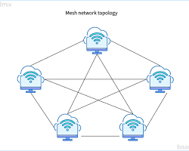

Real-World Application :- Service: WhatsApp / Encrypted Messaging Network.

Why : For privacy and resilience, end-to-end encrypted messaging acts like a full mesh; when you send a message, it travels directly from your device (node) to the recipient's device (another node) across countless other interconnected, untrusted internet paths, ensuring the conversation can continue as long as any connection between the two points exists.

Task 2 :- Create a comparison table listing at least four pros and four cons for each of these topologies: star, bus, ring, mesh. Include a column for 'Best Use Case' and give an example from apps you use (e.g., Instagram, Zomato, Paytm).
ANS :- Star Topology
Pros  (Good Things) | Cons (Drawbacks) | Best Use  Case | Real-World Example
Easy to fix: 1 broken cable won't affect others. | Single point of failure: If the hub breaks, the entire network goes down. | Centralized networks where devices talk to one main server. | Zomato (Phones connect directly to Zomato's main central server).
Easy setup: Just plug a new device into the central hub. | More cables: Needs individual wire runs.
Fast: Dedicated line for each device. | Extra cost: Requires buying switches /routers.
Central control: Easy to monitor all traffic from one spot. | Limited ports: Hub can only take so many plugs.

Bus Topology :-
Pros  (Good Things) | Cons (Drawbacks) | Best Use Case | Real-World Example
Cheapest: Uses very little cable. | Whole network can crash: If main cable snaps, everything dies. | Low-cost, small networks with very basic data needs. | Paytm Soundbox (Simple hardware linked along local billing lines).
Super simple: Easy to link devices in a single line. | Gets slow: Heavy traffic creates data collisions.
No hub needed: Works directly along one cable. | Hard to fix: Hard to locate where the cable broke.
Good for small setups: Quick to install for a few devices. | Short distance: Signal weakens over long wires.

Ring Topology :-
Pros (Good Things) | Cons (Drawbacks) | Best Use Case | Real-World Example
No collisions: Data moves in an orderly 1-way loop. | 1 break stops all: If 1 computer fails, the loop breaks. | Systems needing orderly, structured data loops without traffic jams. | City Traffic Signals (Lights linked in a timed circle to pass updates).
Handles heavy traffic: Doesn't slow down easily under load. | Slow overall: Data passes through every device to reach target.
Equal access: No single device hogs the line. | Hard to expand: Adding 1 device temporarily shuts down the network.
No main hub: Doesn't rely on a central server. | Hard to troubleshoot: Tricky to find the broken node.

Mesh Topology :-

Pros  (Good Things) | Cons (Drawbacks) | Best Use Case | Real-World Example
Super reliable: If 1 line breaks, data takes another path. | Very expensive: Requires a massive amount of cables. | Mission-critical networks where zero downtime is allowed. | Instagram Messages (Data routes across many interconnected servers globally).
Very fast: No bottlenecks due to dedicated links. | Complex setup: Hard to wire every device to every other device.
Highly secure: Direct node-to-node privacy. | Wasted capacity: Extra wires sit idle most of the time.
No central failure: Network stays up even if nodes crash. | Hard to manage: Complex maintenance due to many links.

Task 3 :- Imagine you are designing a new multiplayer mobile game like PUBG or Free Fire. Choose a suitable network topology for the game servers and justify your choice in 3-4 lines, mentioning how it would impact speed, reliability, and cost.

ANS :-

I’d choose a Dedicated Client-Server topology (using centralized authoritative servers).

Here’s why :-

- Speed & Reliability :
Servers handle all game physics and player data centrally, keeping sync fast, preventing cheating/lag switching, and ensuring stable connections for 50–100 players simultaneously.
- Cost :
Server hosting and bandwidth costs are significantly higher than peer-to-peer options, but it’s a necessary investment to deliver a smooth, fair competitive experience.

Task 4 :- Given this scenario: A small Flipkart-style warehouse wants to connect 8 computers for order processing and inventory updates. Recommend a network topology, sketch a quick diagram, and explain your reasoning in 2-3 lines.

ANS :-
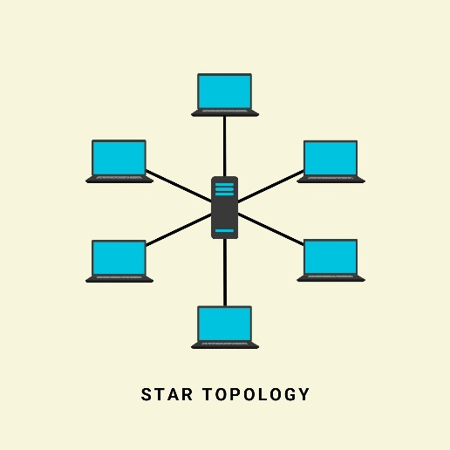

Reason :-
- Reliability :
If one computer or cable fails, the other 7 keep processing warehouse orders without stopping.

- Easy Setup & Scale :
It's cheap to set up for 8 systems, easy to find network faults, and simple to add more PCs as the warehouse grows.

